NANDINI ENGINEERS – A’bad.
E-mail : pinaldj1812@yahoo.com

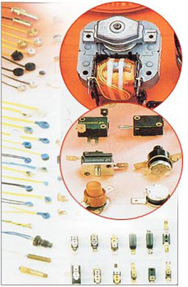
  CONTROL UNITS :
  TEMP. CONTROL
  TEMP. SWITCHES
  CURRENT LIMITERS
  THERMOSTATE, TEMP. REGULATORS
  THERMAL FUSES
  PTC, MOTOR PTC, NTC, MOXIE
  COMPONEBTS TO CUSTOMERS REQUEST
  VARISTORS
  TEMP. PROBES.
  THERMISTOR

 |  |  |  |  |  |  |  | 

TEMPERATURE SWITCH
 |  | open construction  for use as control, protection or limit device,  or with electrical self-hold.  Vnom 110 V, 250 V, 50-60 Hz  6-24 V DC  Inom 1A to 16 A  Switching temperatures:  40°C to 160°C |  | 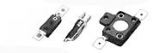
 |  | TEMPERATURE SWITCH
 |  | for electronic applications  Vnom 110 V, 250 V, 50-60 Hz,  6-24V DC  Inom 2 A to 6 A  Switching temperatures:  50°C to 150°C |  | 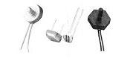
 |  | TEMPERATURE SWITCH
 |  | enclosed construction  for use as control, protection or limit device or with electrical self-hold  Vnom 110 V, 250 V, 400 V, 50-60 Hz,  6-24V DC  Inom 1A to 16 A  Switching temperatures:  -20°C to 180°C |  | 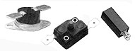
 |  | TEMPERATURE SWITCH
 |  | for high temperatures  cut-out, limit device  Vnom 110 V, 250 V, 400 V 50-60 Hz,  6-24V DC  Inom 1 A to 20 A  Switching temperatures:  50°C to 425°C |  | 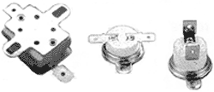
 |  | TEMPERATURE SWITCH
 |  | protection for motor/transformer windings  Vnom 110 V, 250 V, 400 V, 50-60 Hz,  Inom 1A to 20 A  Switching temperatures:  50°C to 180°C |  |   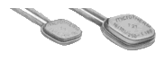

 |  | TEMPERATURE-/ CURRENT SWITCH
 |  | with adaptable current sensitivity  used as current/time element, protector  limiter or with electrical self-hold  Vnom 12-30 V DC, 110 V, 250 V, 400 V 50-60 Hz,  Inom 2A to 16 A  switch off time up to 60 secs |  | 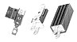
 |  | TEMPERATURE SWITCH
 |  | protection for motor/transformer windings  sensing control (current/temperature)  Vnom 110 V, 250 V, 50-60 Hz,  Inom 1A to 20 A  switching temperatures:  50°C - 180°C |  | 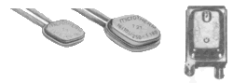
 |  | THERMAL FUSES
 |  | Vnom 110 V, 250 V, 50-60 Hz,  Inom 1A to 7A  Switching temperatures:  98°C to 335°C  Vnom 110 V, 250 V, 50-60 Hz,  Inom 1A to 16 A  Switching temperatures:  72°C to 240°C |  |  |  | 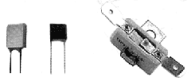
 |  | NTC-THERMISTORS
 |  | with step function characteristic (Moxie)  for electronic applications  Temperature range:  57°C to 85°C |  |  |  |  |  | 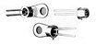
 |  | TEMPERATURE PROBES
 |  | surface mounted, screw-in,  immersion types  with NTC or PTC resistances or as PT100  Measuring range:  -50°C to 260°C |  |  |  |  |  | 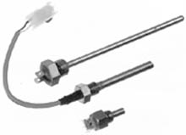
 |  | PTC-THERMISTORS
 |  | Temperature Sensor for motor protection, single, twin and triplet versions  Vb max. 25V per Chip  Response temperatures  from 80°C to 180°C |  |  |  |  |  | 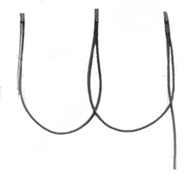

NANDINI ENGINEERS / MR.PINAL JOSHI. 98252 15244. E-mail : pinaldj1812@yahoo.com
F-22, SARTHI COMPLEX, OPP. BRTS BUS STOP, JASODA NAGAR CHAR RASTA, AHMEDABAD – 382445. GUJ. INDIA.

